How to Use the Cultural Resources Environmental Vulnerability Assessment Tool (CREVAT)
Contents
Navigation 1
Add your Own Data 2
Popups 2
Charting Vulnerability of Systems 3

Navigation
Perform navigation using the buttons, in the top left-hand corner, or the scroll wheel on your mouse.

Clicking the icon will return you to the default extent of the application.

The icon zooms you to your current location.

Clicking the icon takes you to the Bookmark submenu. Bookmarks are present for certain sites in the region. Clicking one of the bookmarks will take you to that location. You can add your own bookmarks for frequently visited locations.
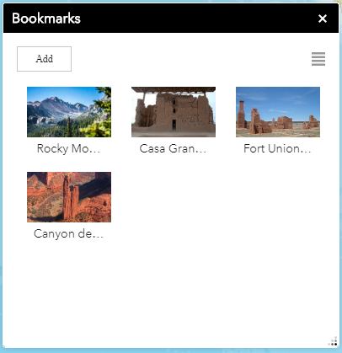
You can turn layers on and off using the Layer icon in the top right-hand corner. To see legends for the activated layers, click the Legend icon 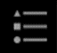.
Click the to access the Splash Page again. Here you will find various documents related to the assumptions and inner workings of CREVAT.

Add your Own Data
Clicking the icon opens the Add Data submenu. Add your own data, temporarily, to the web application. Data is removed when you exit the application. Usable data types include those with .shp, .csv, .kml, .gpx, .json, and .geojson file extensions. You can also add data from other users by clicking the search option.

Popups
Many of the layers in CREVAT have popups associated with them. To access a popup first turn on the layer of interest in the Layer menu found in the top right corner of CREVAT. Click on your area of interest and a popup will appear associated with the location outlined in cyan. If multiple layers with popups are present an arrow will appear in the top right corner of the popup. Clicking this arrow will allow you to access the popup information for the layers below the top layer.
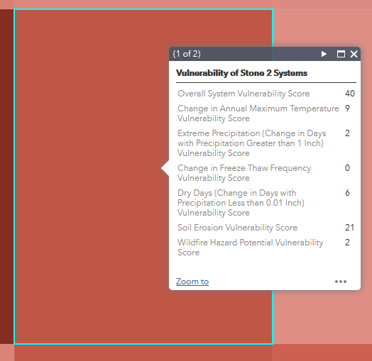
Figure 1: Many of the layers in CREVAT have popups associated with them. You can access a popup by loading a layer and clicking on a location. If multiple layers with popups are active an arrow will appear in the top right corner of the popup allowing you to cycle through popups for other active layers. This popup shows the overall environmental vulnerability of Stone 2 systems in this location. The vulnerability scores associated with each exposure are also present and sum to the overall score.

Charting Vulnerability of Systems
Clicking one of the following icons will take you to the Chart submenu for that system.
- 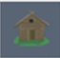Click this icon to chart the environmental vulnerability of Wood systems.
- Click this icon to chart the environmental vulnerability of Arch Site systems.
- 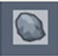Click this icon to chart the environmental vulnerability of Stone systems.
- 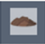Click this icon to chart the environmental vulnerability of Earth systems.
- Click this icon to chart the environmental vulnerability of Brick systems.
- 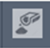 Click this icon to chart the environmental vulnerability of Concrete systems.
Select one of the layers on submenu to chart. Check the Use spatial filter to limit features option and click the Only features intersecting a user-defined area bubble. Use thebutton to select a location on the map or one of the other icons to select an area on the map. Click Apply to create a chart for that point or area.
You can hover over the pie chart to see the percentage of each layer within the area of interest.
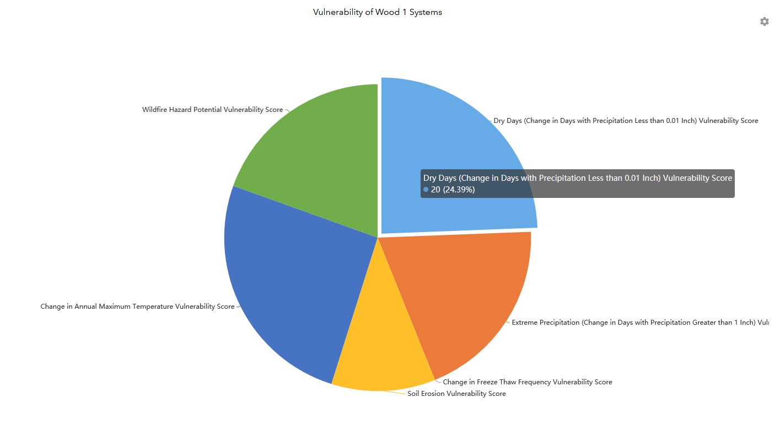
Figure 2: The pie chart will show you the vulnerability score of the selected system to each exposure. Adding the exposure vulnerability scores together will give you the overall environmental vulnerability score for the selected system in that location.

Print a Map
Clicking the icon opens the print menu.
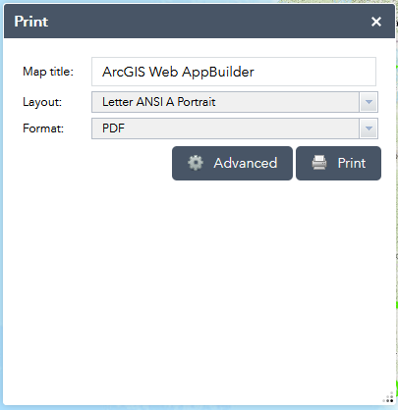
Figure 3: Use the print icon to create a map of your current display including a scale bar, north arrow, and legend for any active layers.
Enter a Map title. You can change the Layout Type and Output Format. Clicking the Advanced button allows you to add Author information and tweak Print Quality. Once you set click Print. A load bar will appear that says Creating print. The title of your map will appear when the printing process is complete. Click the title of your map to view the output. The output will appear as another tab in your browser. Use your browsers print options to save a copy of the map to your computer.

Download Data
Some datasets can be downloaded from CREVAT. If you click on an active layer a popup will appear. Layers that can be downloaded will have a “Click to Download Data” link at the bottom.
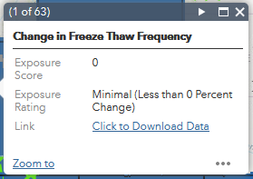
Figure 4: Click the Click to Download Data link to acquire a copy of data layer and use it in your own GIS software.
Currently only the Exposure Variables – Scored Layers can be downloaded. Other datasets will be available in the future or upon request.

