How to Use the Cultural Resources Environmental Vulnerability Assessment Tool (CREVAT) Dashboard
Contents
Selecting a Park Unit and System 1
Interpreting the Graphics 2
Compare to Nearby Parks 3
Examining the Exposures 4

Selecting a Park Unit and System
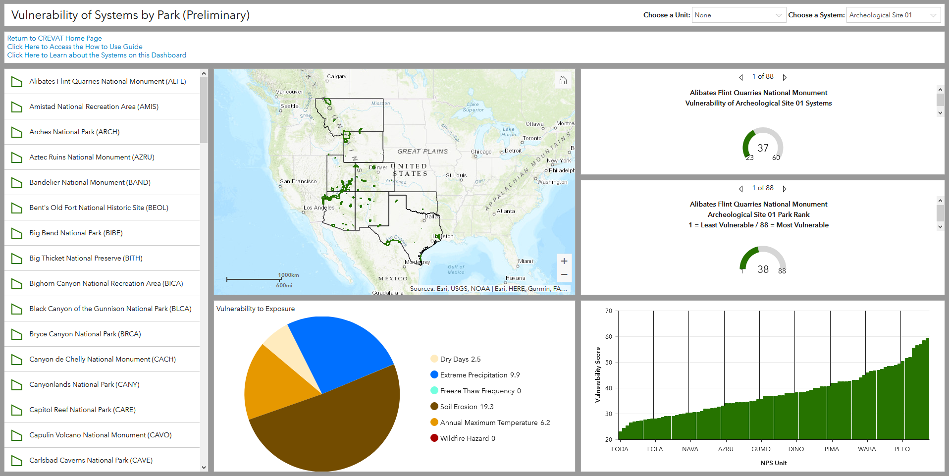
Figure 1: Current layout of National Park Service (NPS) Park Dashboard designed to allow users to compare parks for a specific system type.
- In the top right corner, select your unit and system of interest from the two drop-down lists.
- Once you select a unit and system the bar chart (on the bottom right), the pie chart (at the bottom), the gauges (on the right), and the list (on the left) all update.
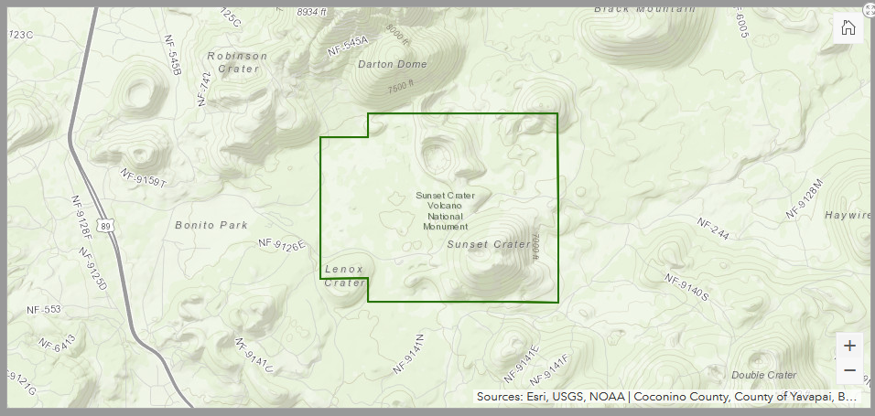
- Click the unit of interest in the list (on the left side) and the map will zoom into the boundaries of the unit selected.
Figure 2: When Sunset Crater Volcano National Monument is selected from the drop-down list the list (on the left side) is updated. Clicking on the unit in the list makes the map zoom into the unit boundaries on the map.

Interpreting the Graphics
- The bar chart (on the bottom right) shows the average vulnerability score of the system in the unit selected from the drop-down list. If you hover over the column the score for the unit is displayed.
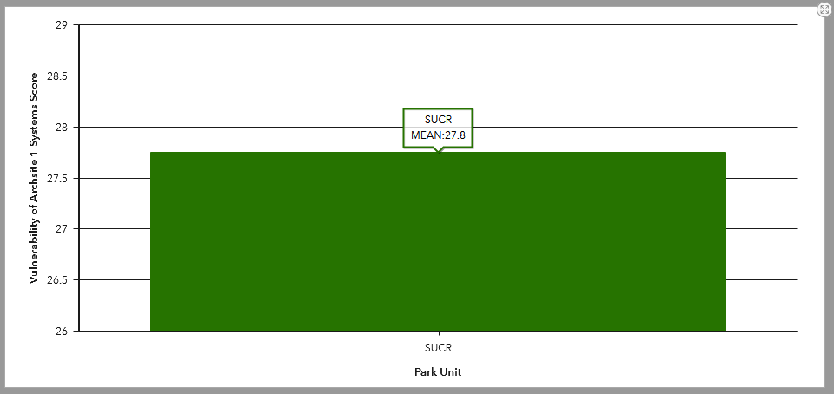
Figure 3: Vulnerability score of Archeological Site 1 systems in Sunset Crater Volcano National Monument in chart form.
- The top gauge (on the right side) shows the average vulnerability score of the system in the selected unit in comparison to the minimum and maximum scores for the units in the Intermountain Region.
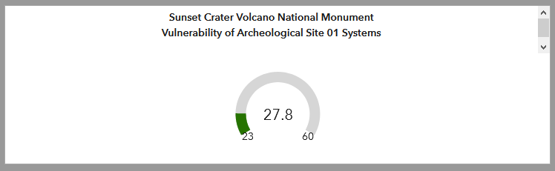
Figure 4: This gauge shows the average vulnerability score of Archeological Site 1 systems in Sunset Crater Volcano National Monument along with the minimum unit score (23) and maximum unit score (60) in the Intermountain Region.
- The bottom gauge (on the right side) shows the rank of the selected unit out of the 88 units in the Intermountain Region for the system.
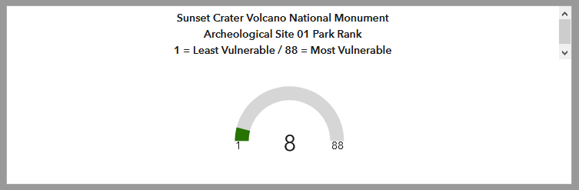
Figure 5: This gauge shows the rank for Sunset Crater Volcano National Monument for Archeological Site 1 systems in comparison to the other units in the Intermountain Region. The least vulnerable unit for the system type will have a rank of 1, while the most vulnerable park for the system type will have an 88.

Compare to Nearby Parks
- You can also compare your unit of interest to other units by zooming out on the map. As you zoom out additional units will be displayed on the bar chart (at the bottom right).
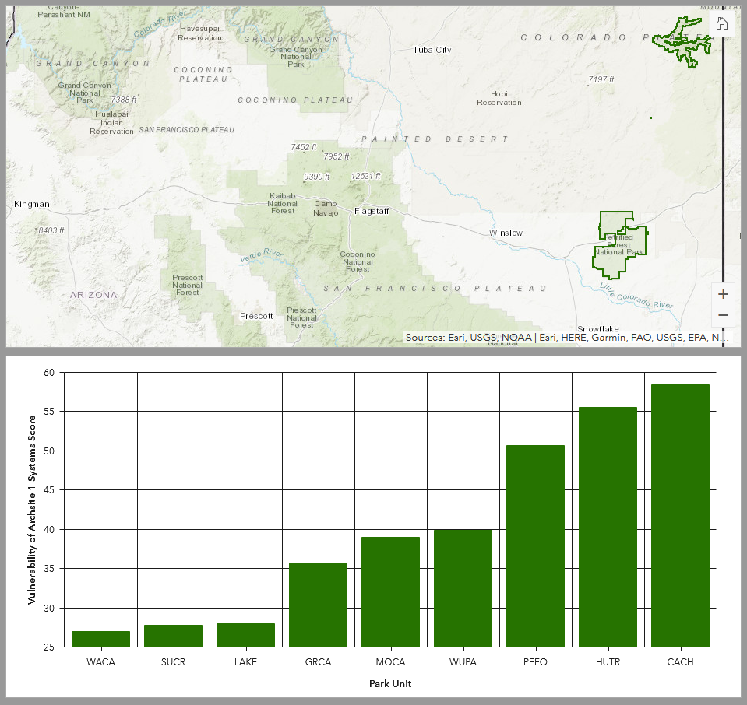
Figure 6: As you zoom out from Sunset Crater Volcano National Monument the surrounding units will begin to appear on the bar chart.

Examining the Exposures
- The pie chart (at the bottom) shows the vulnerability scores associated with each exposure in the selected unit for the selected system. A vulnerability score is equal to exposure score times sensitivity score for the selected system. Hover over a slice of the pie chart to see the exposure vulnerability score and percentage of the total system vulnerability score (shown in the gauge at the top right) in the selected unit.
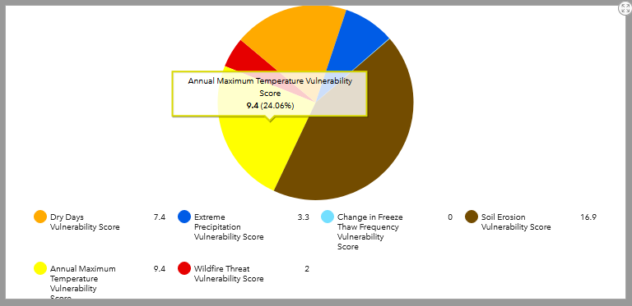
Figure 7: The pie chart at the bottom of the dashboard shows the various vulnerability scores associated with each of the six exposures. If you hover over a slice of the chart it shows the percentage of the total vulnerability score for the system in the selected unit.
- You can change your system of interest in the drop-down list and the charts and gauges will update to the system selected.

